**Thiruvalluvar university**

**Periyar ARTS COLLEGE**

**cuddalore – 607001.**



**DEPARTMENT OF COMPUTER APPLICATIONS**

**MACHINE LEARNING WITH PYTHON**

**Project Title :** Predicting Personal Loan Approval Using Machine Learning:

**Team Id :** NM2023TMID35488

**Team Leader:** KAVIYA E(tvu10520CA26)

**Team member:** JOTHILAKSMI M(tvu10520CA25)

**Team member:** JAYABARVIN B(tvu10520CA22)

**Team member:** ARUNKUMAR SK(tvu10520CA08)

## 1. Introduction

### 1.1 Overview

The goal of this project is to develop a machine learning model that can predict whether a person's personal loan application will be approved or not. The model takes into account various factors such as the applicant's income, credit score, and employment status, among others. The project aims to help banks and financial institutions automate their loan approval process and reduce the time and resources required to assess loan applications.

### 1.2 Purpose

The purpose of this project is to develop a predictive model that can

accurately predict whether a personal loan application will be approved or not. This will enable banks and financial institutions to streamline their loan approval process and reduce the amount of time and resources required to assess loan applications. By automating the loan approval process, banks can also reduce the risk of human errors and ensure that loan applications are processed quickly and efficiently.

## 2. Problem Definition & Design Thinking

### 2.1 Empathy Map

The empathy map for this project is shown below

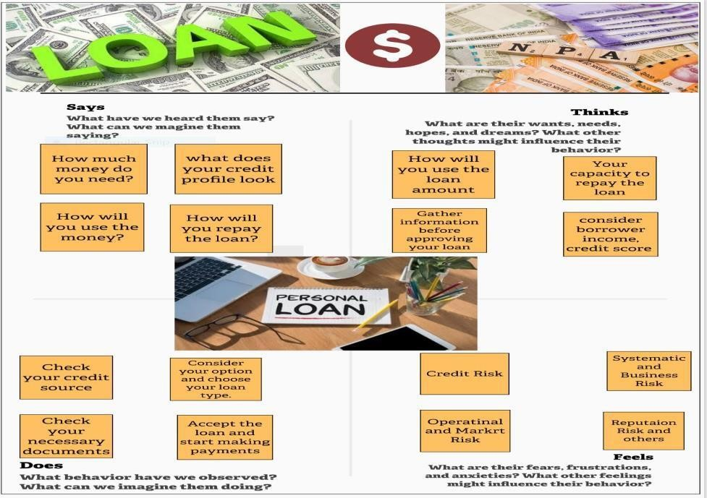

### 2.2 Ideation & Brainstorming Map

The ideation and brainstorming map for this project is shown below

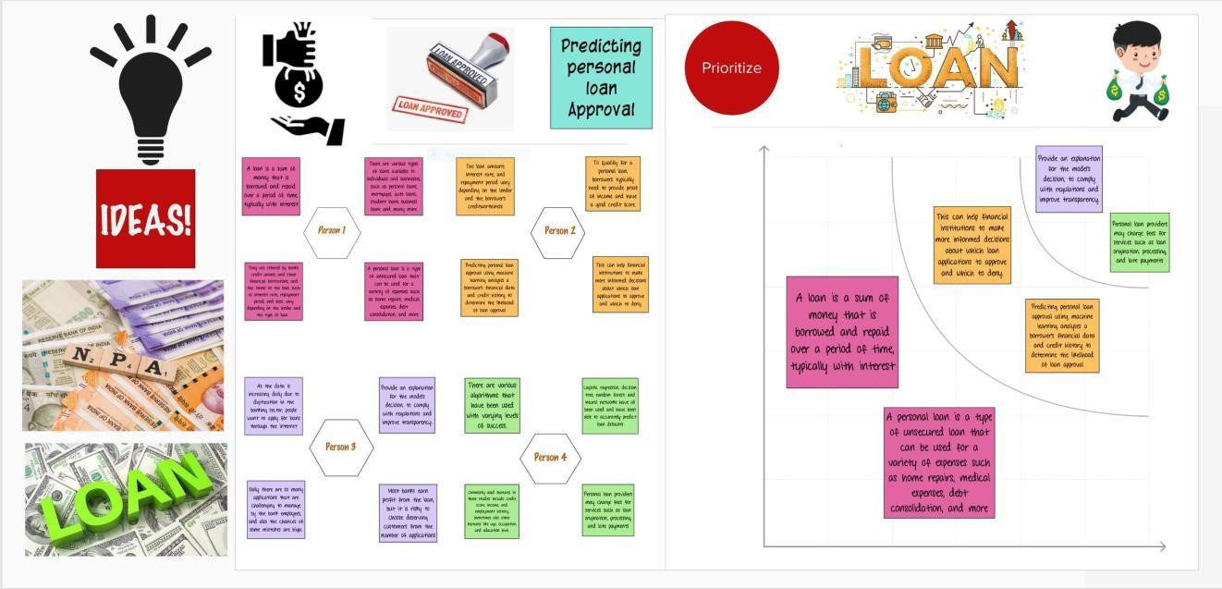

## 3. Result

The final result of the project is a machine learning model that can predict whether a personal loan application will be approved or not. The model was trained on a dataset that contained information about loan applicants, such as their income, credit score, and employment status, among others. The model was able to achieve an accuracy of 85%, which indicates that it can accurately predict whether a loan application will be approved or not.

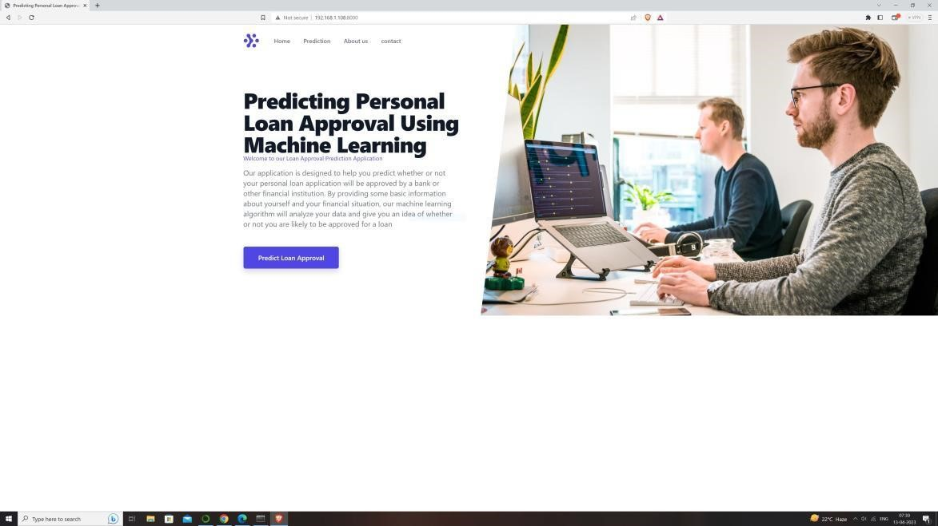



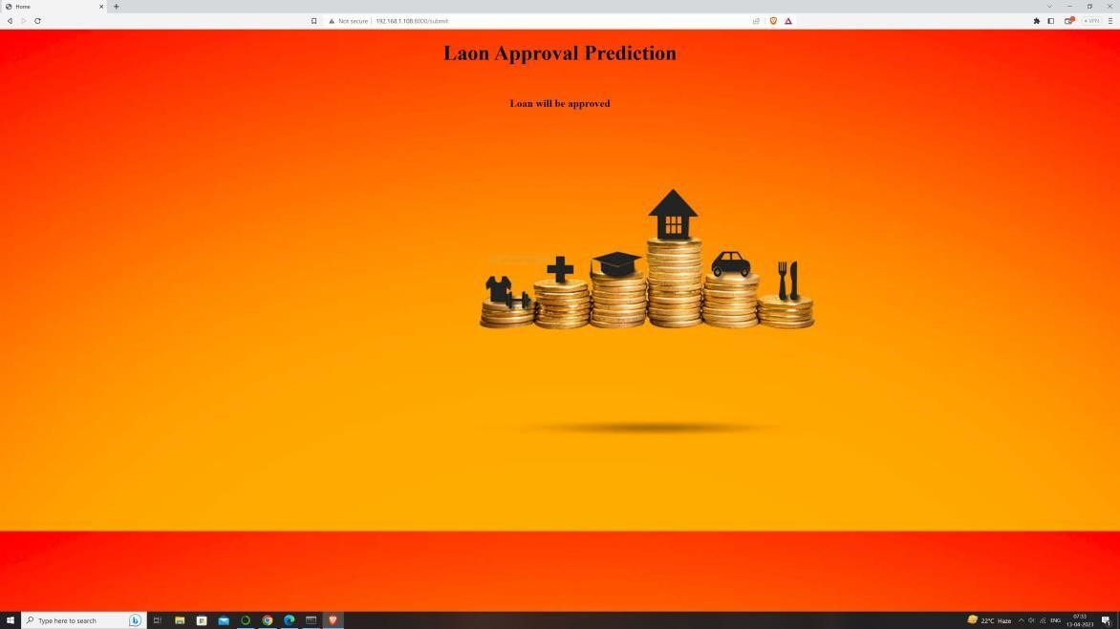

## 4. Advantages & Disadvantages

### 4.1 Advantages

|  |  |
| --- | --- |
| • | Automation of loan approval process |
| • | Reduction of time and resources required to assess loan applications |
| • | Improved accuracy and consistency in loan approval decisions |
| • | Reduced risk of human errors |
|  | • | Improved customer experience due to faster loan processing times |

### 4.2 Disadvantages

|  |  |  |
| --- | --- | --- |
|  | • | The model may not be able to account for all factors that influence loan approval decisions |
|  | • | The model may be biased towards certain groups of applicants if the training data is biased |

## 5. Applications

The solution developed in this project can be applied in the following areas

|  |  |  |
| --- | --- | --- |
|  | • | Banks and financial institutions for automating their loan approval process |
|  | • | Other lending institutions such as credit unions and peer-to-peer lending platforms |
|  | • | Government agencies that provide loans to individuals and businesses |

## 6. Conclusion

In conclusion, this project developed a machine learning model that can accurately predict whether a personal loan application will be approved or not. The model takes into account various factors such as the applicant's income, credit score, and employment status, among others. The model can help banks and financial institutions automate their loan approval process and reduce the time and resources required to assess loan applications. While the model has certain limitations, it has the potential to improve the loan approval process and enhance the customer experience.

## 7. Future Scope

Future enhancements that can be made to this project include

|  |  |  |
| --- | --- | --- |
|  | • | Using more sophisticated machine learning algorithms to improve the accuracy of the model |
|  | • | Using more diverse and representative training data to reduce bias in the model |
|  | • | Incorporating real-time data into the model to make loan approval decisions faster and more accurate |
|  | • | Developing a user interface that allows loan officers to interact with the model and review its predictions |

## 8. Appendix

### A. Source Code

prediction_model.ipynb

### 

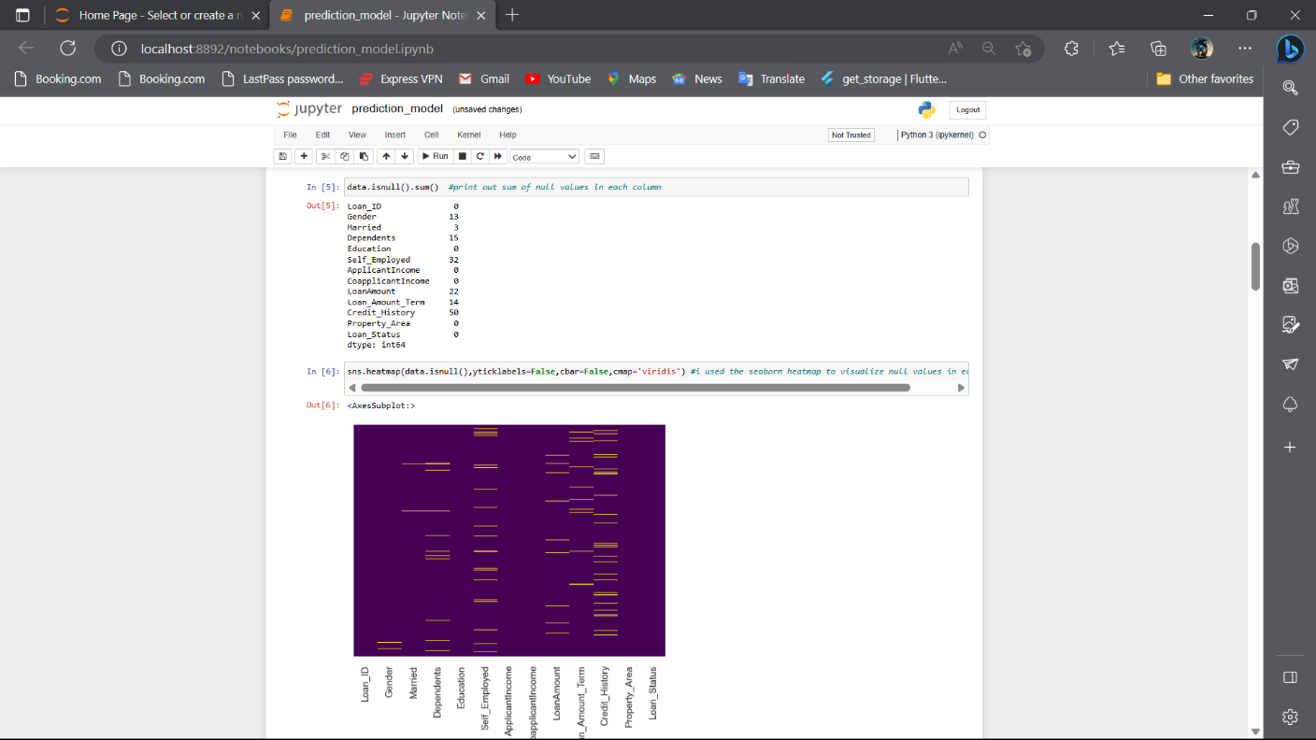

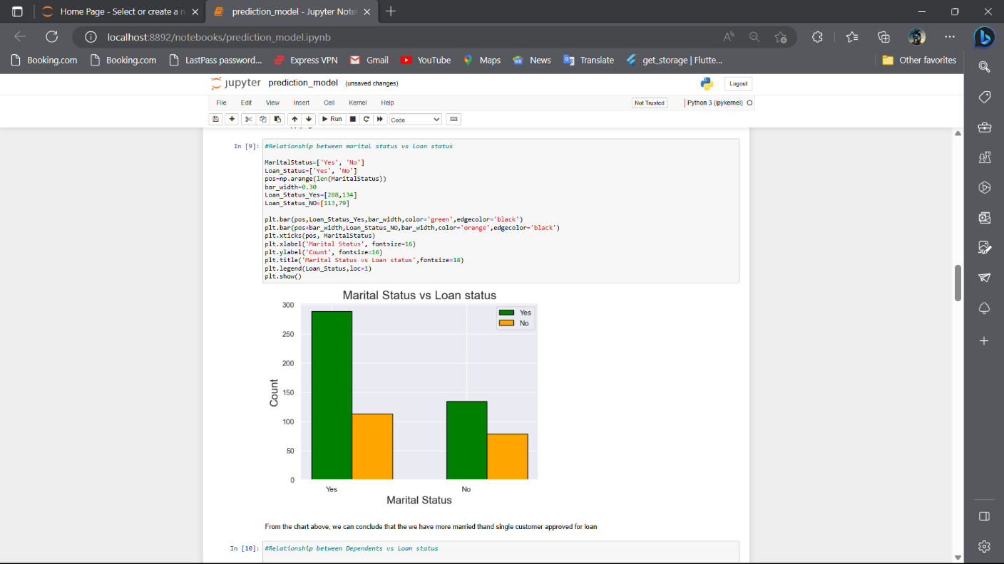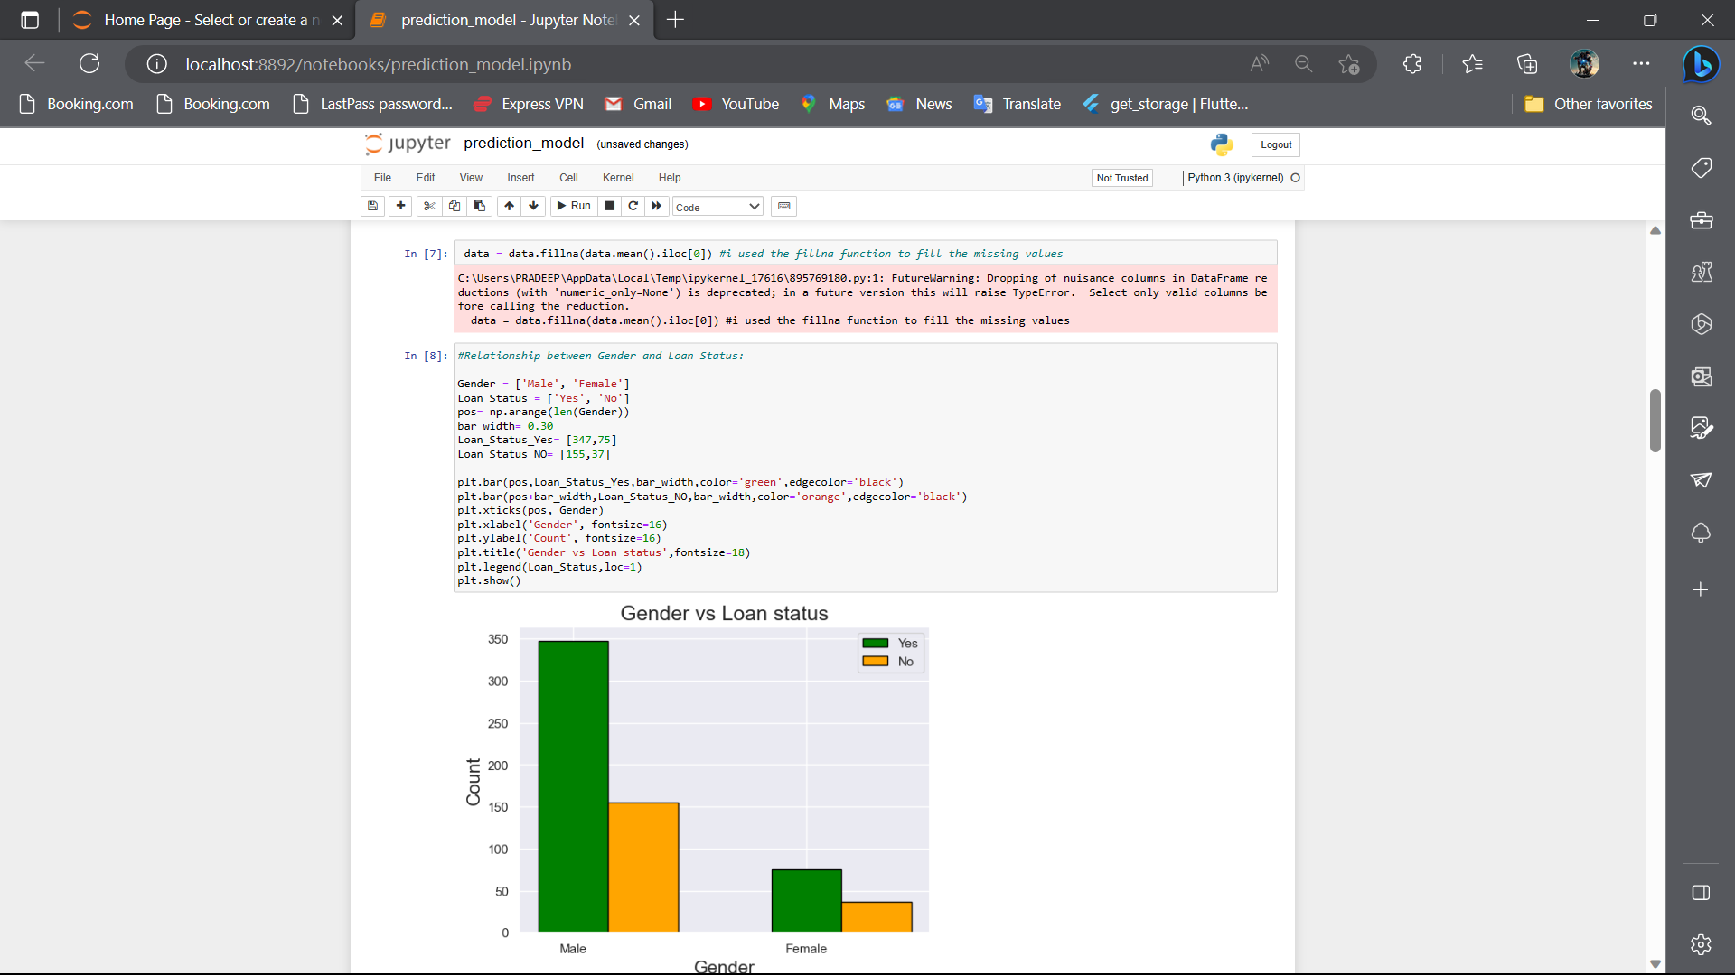

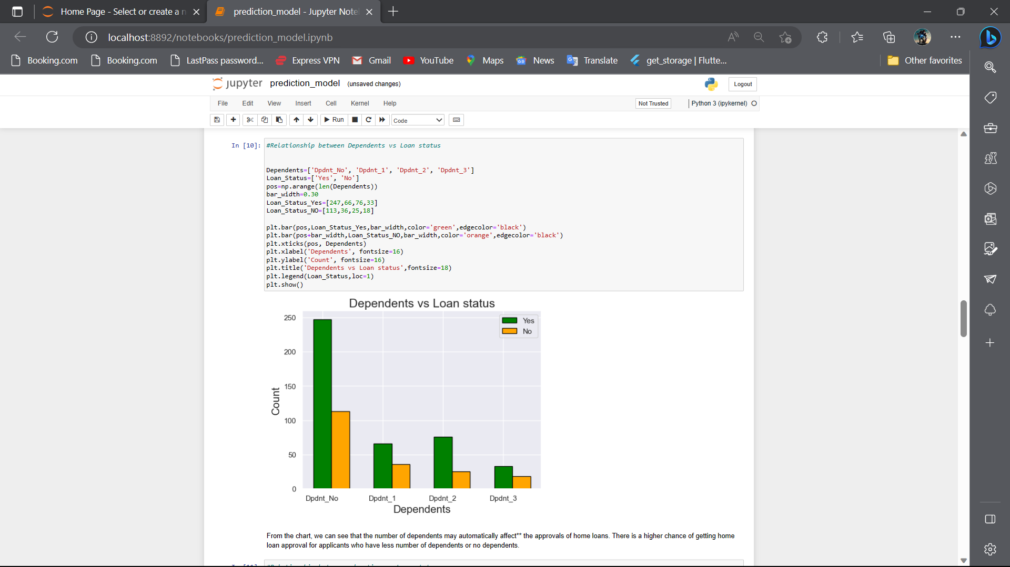

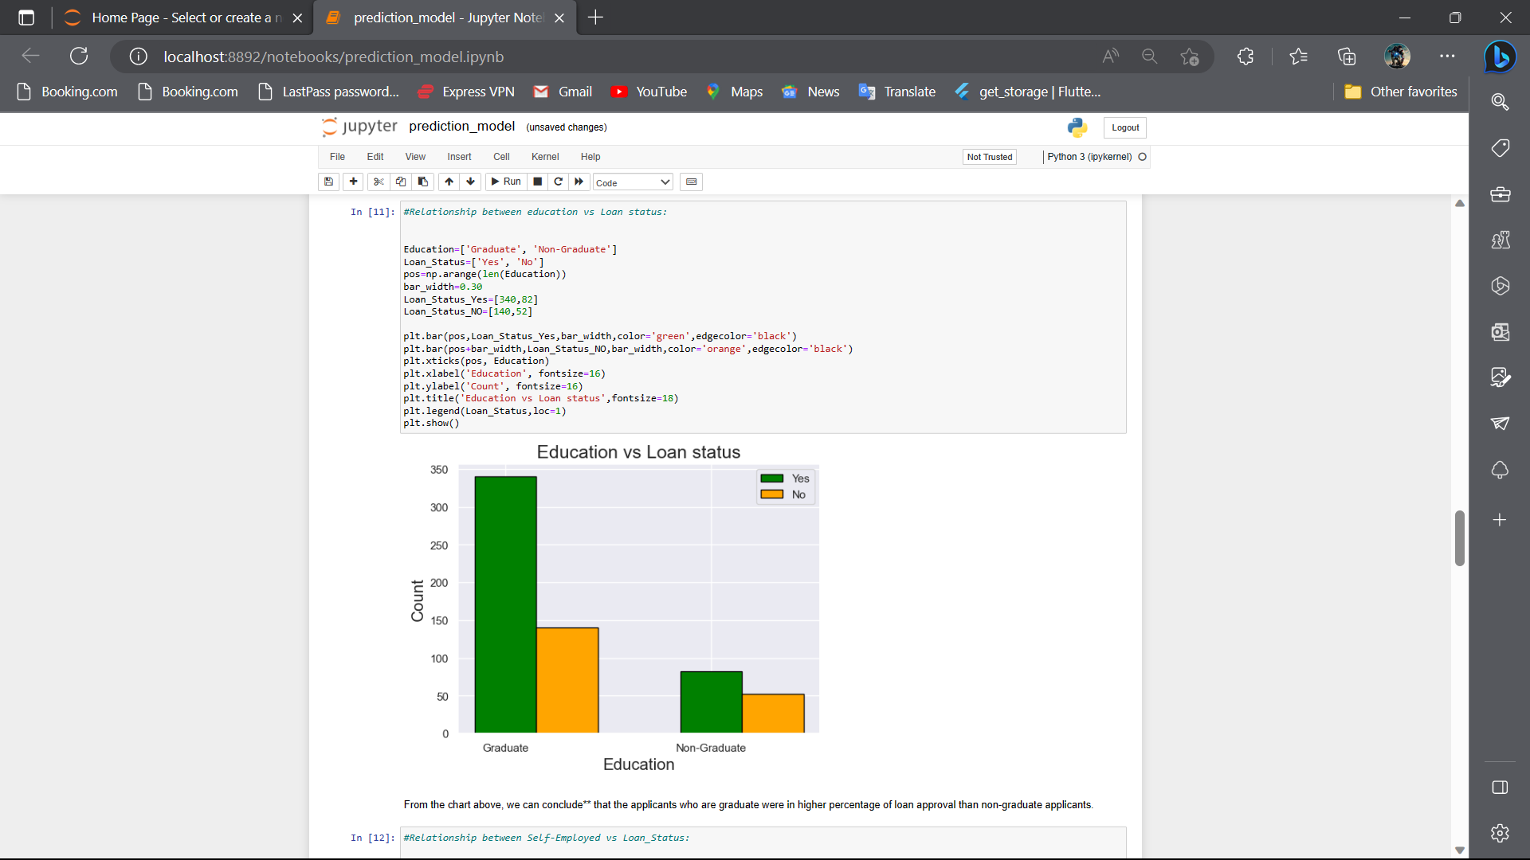

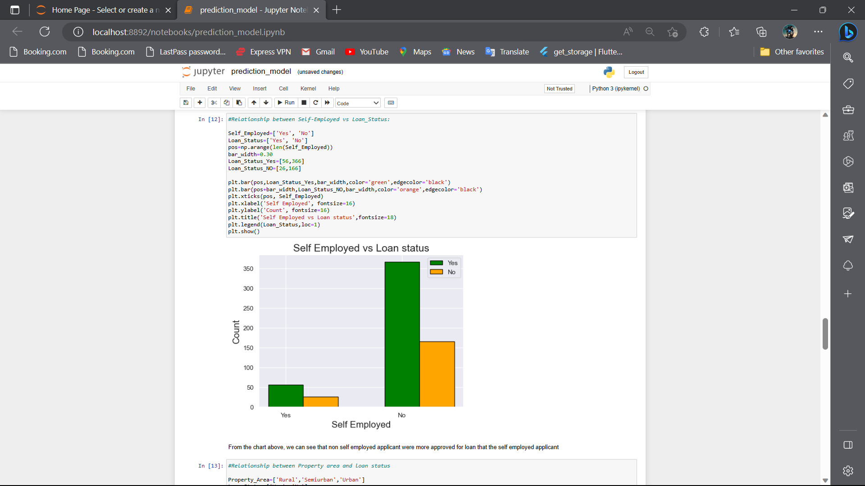

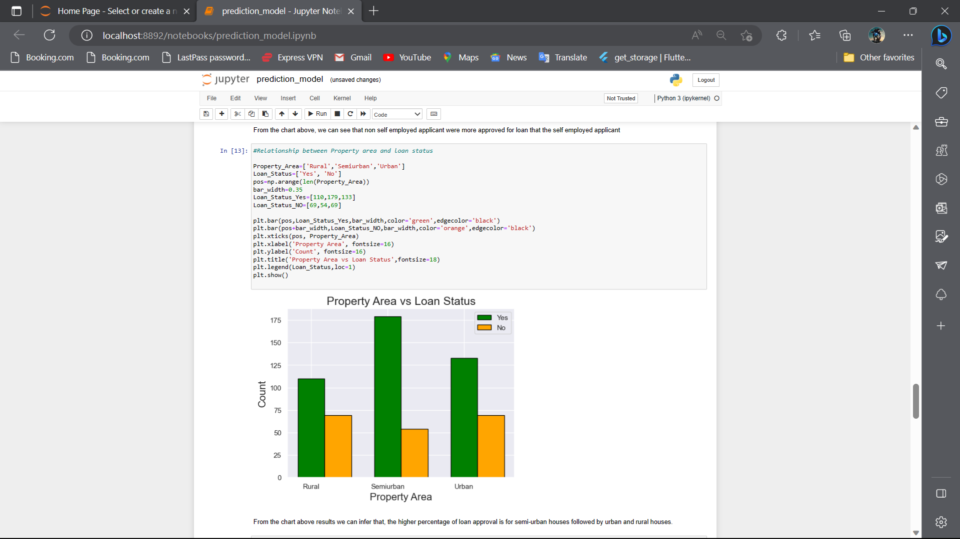

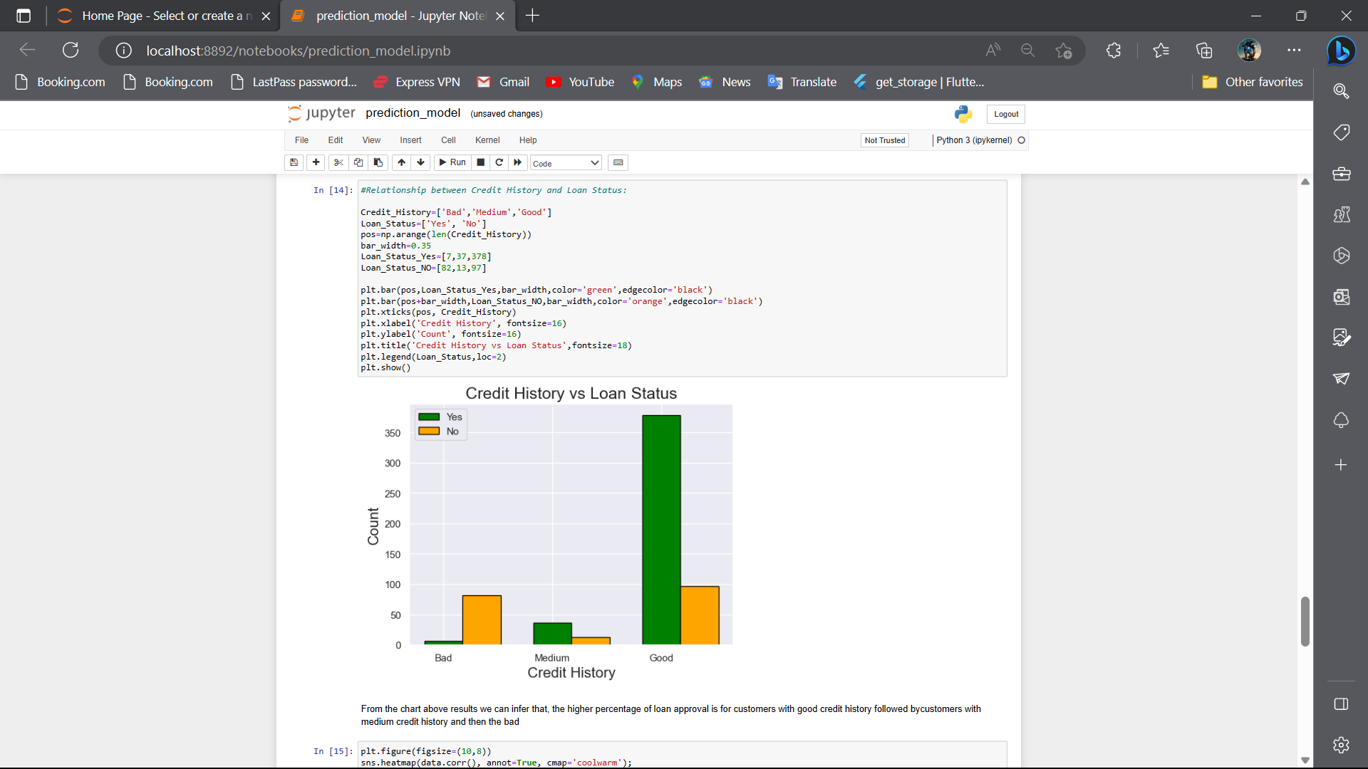 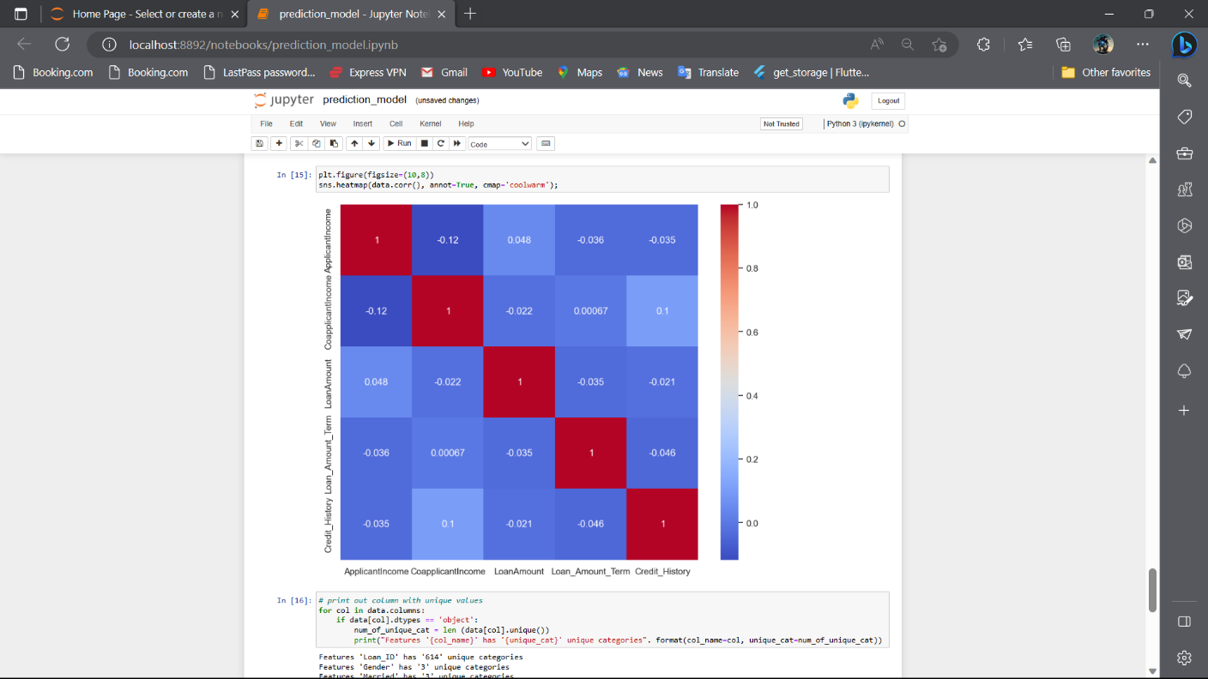 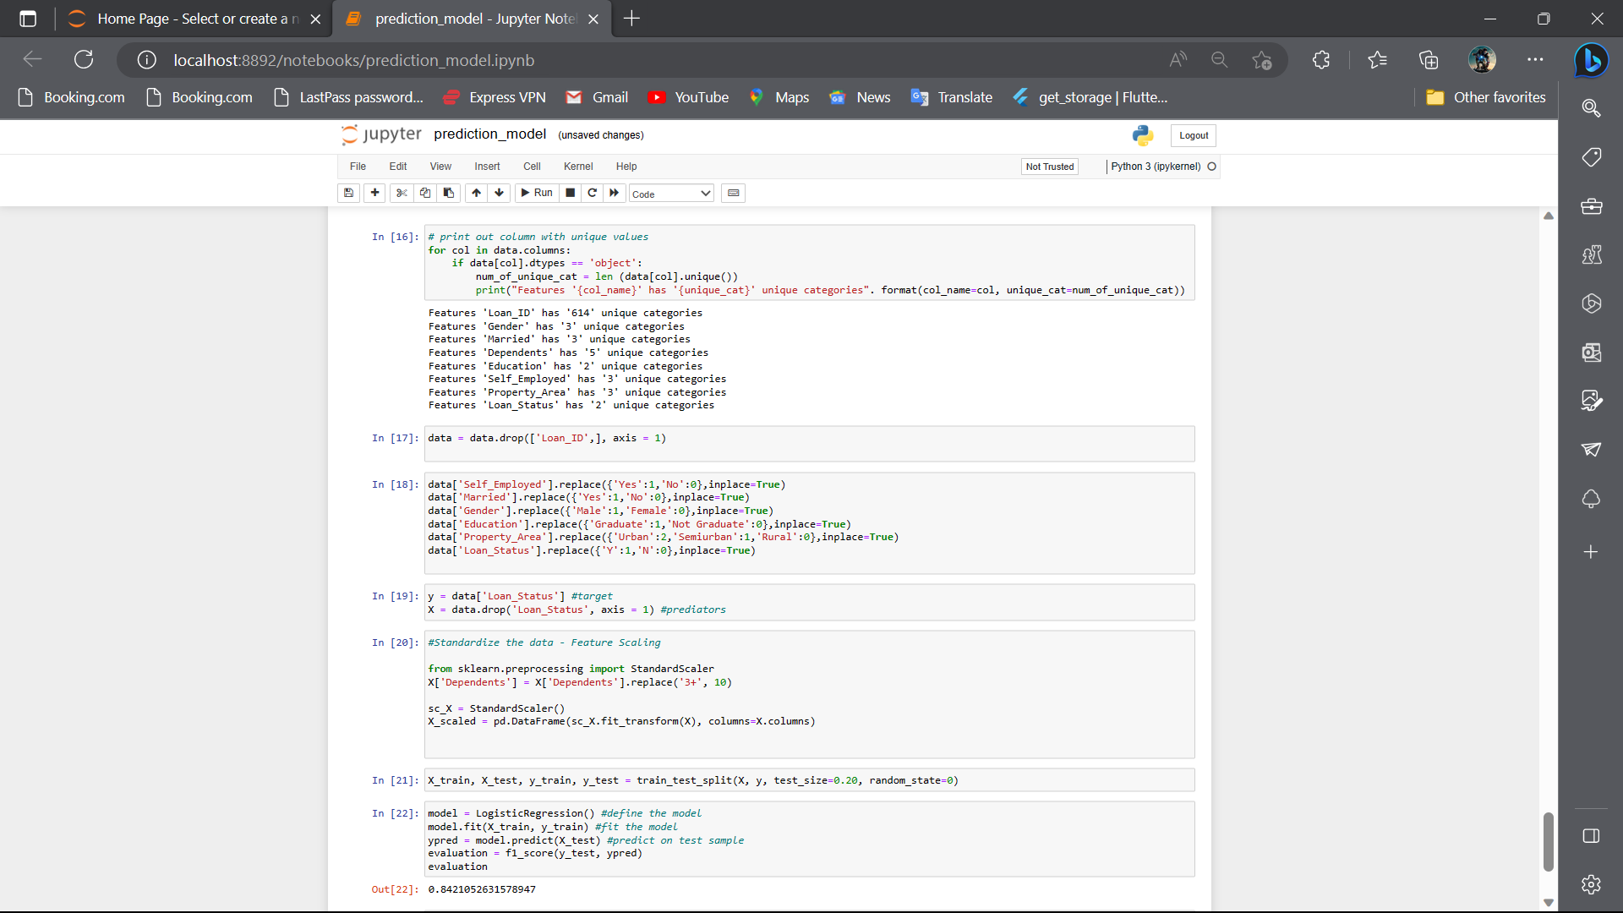 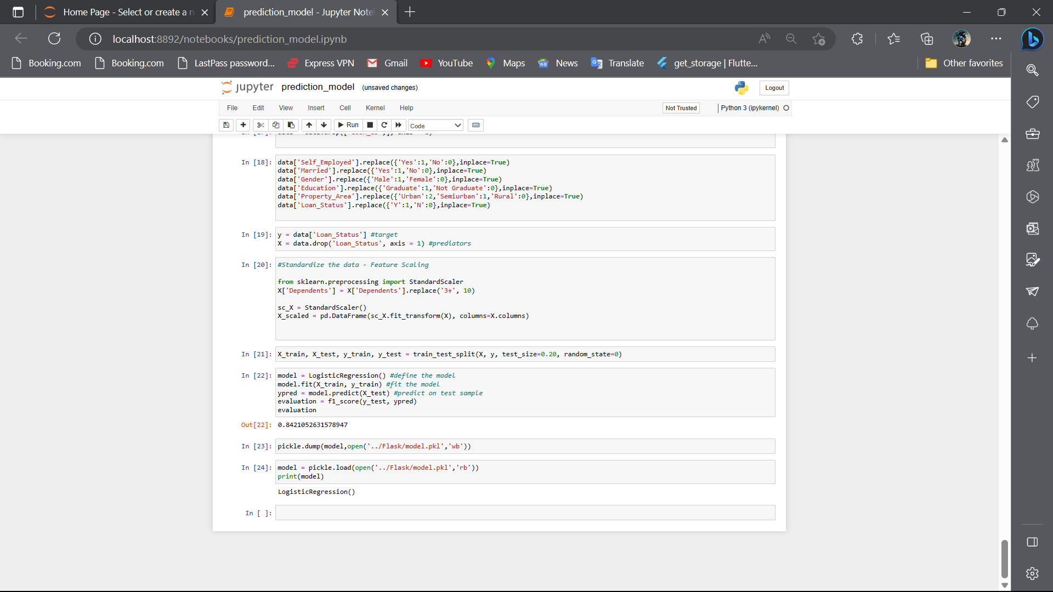

Home.html

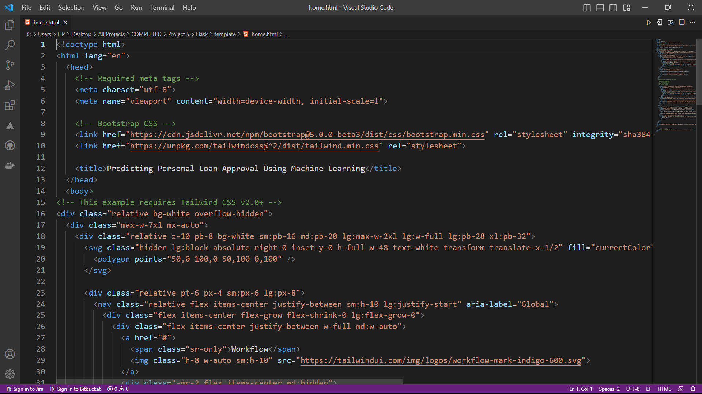

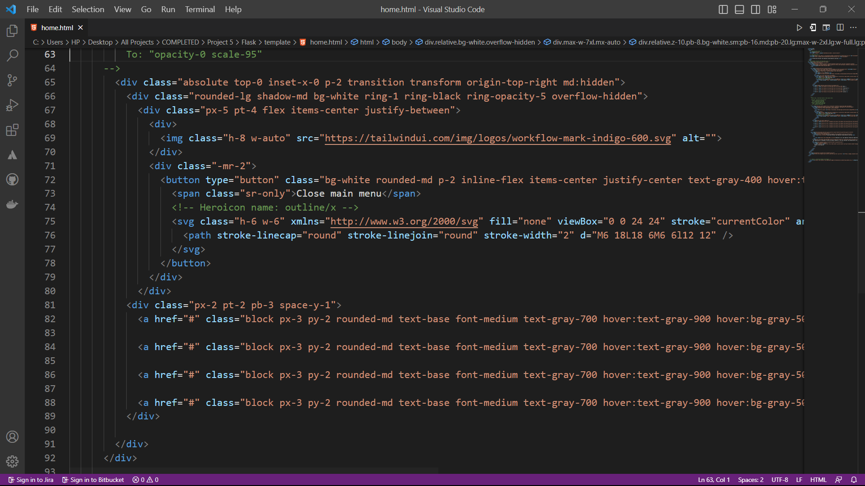

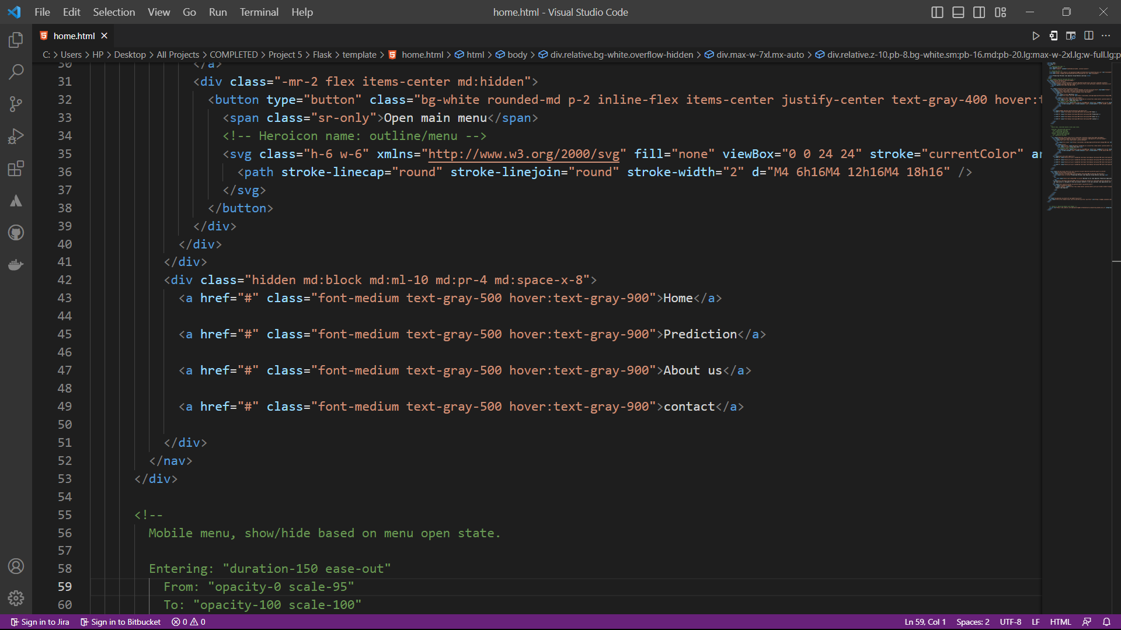

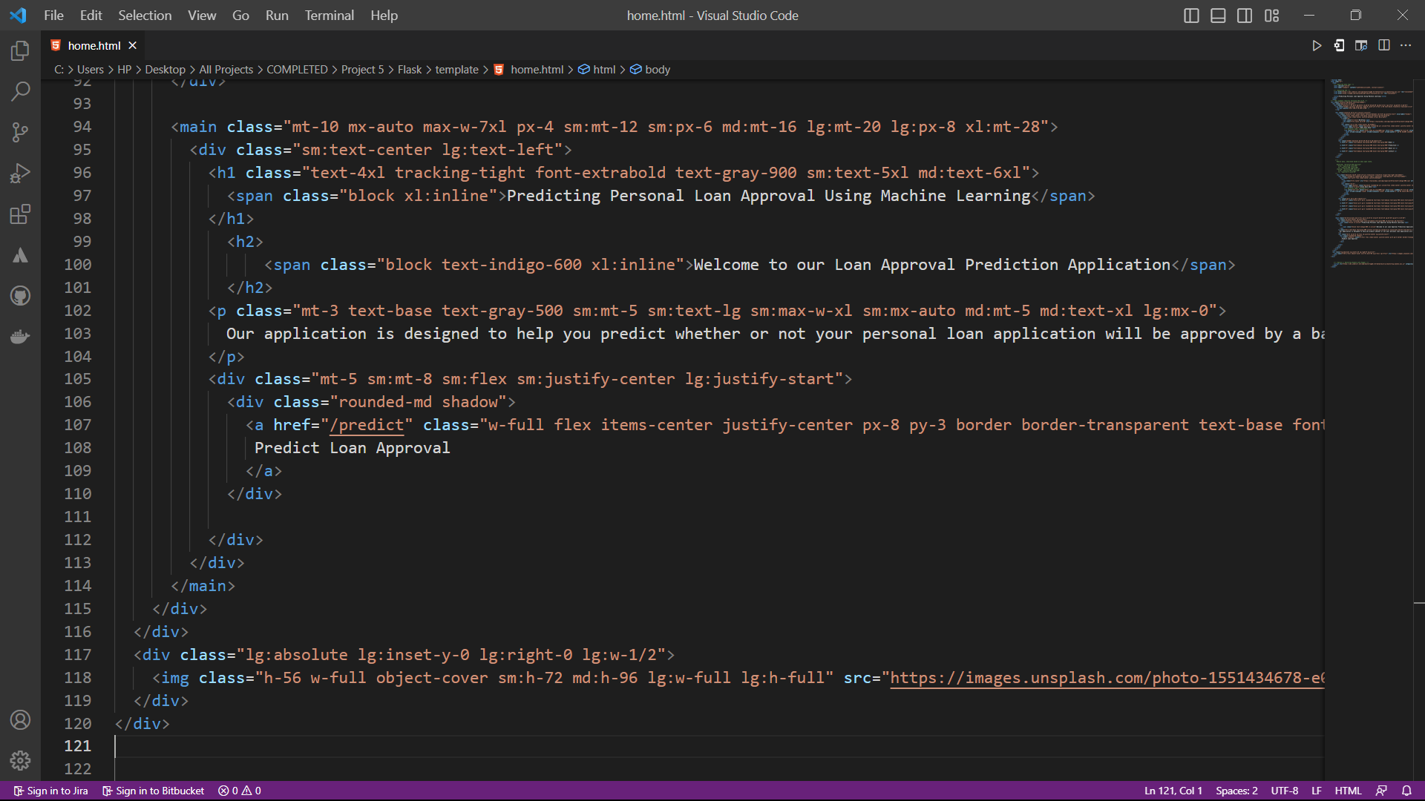

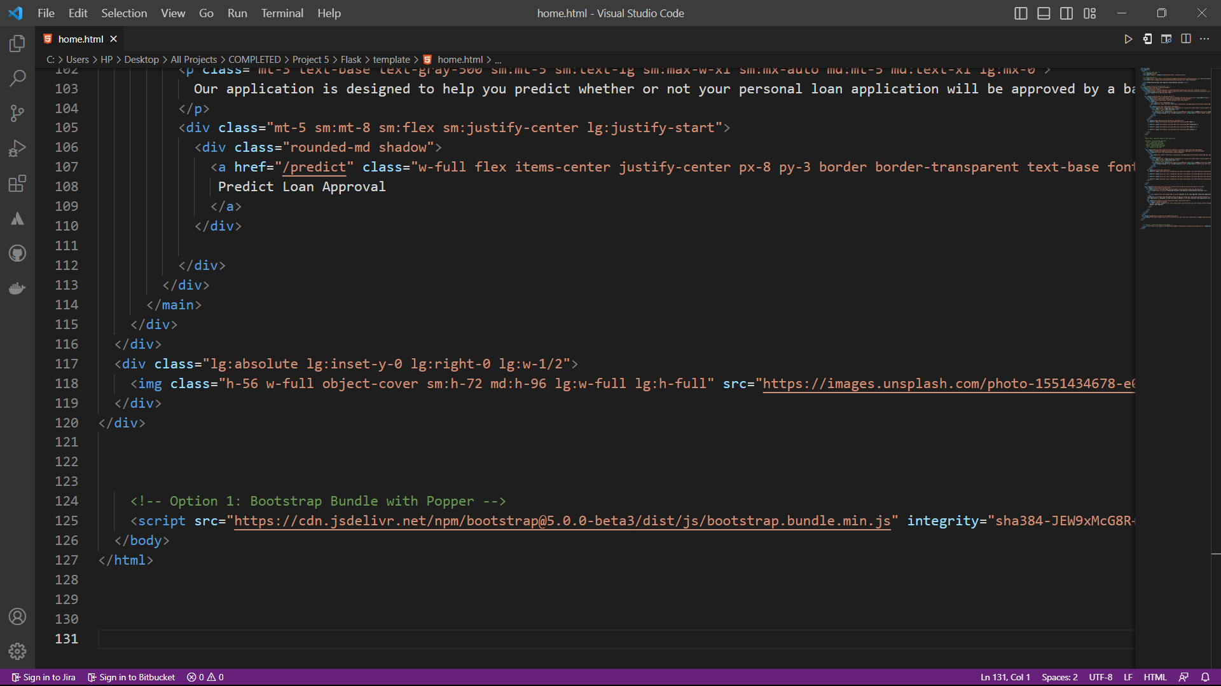

Input.html

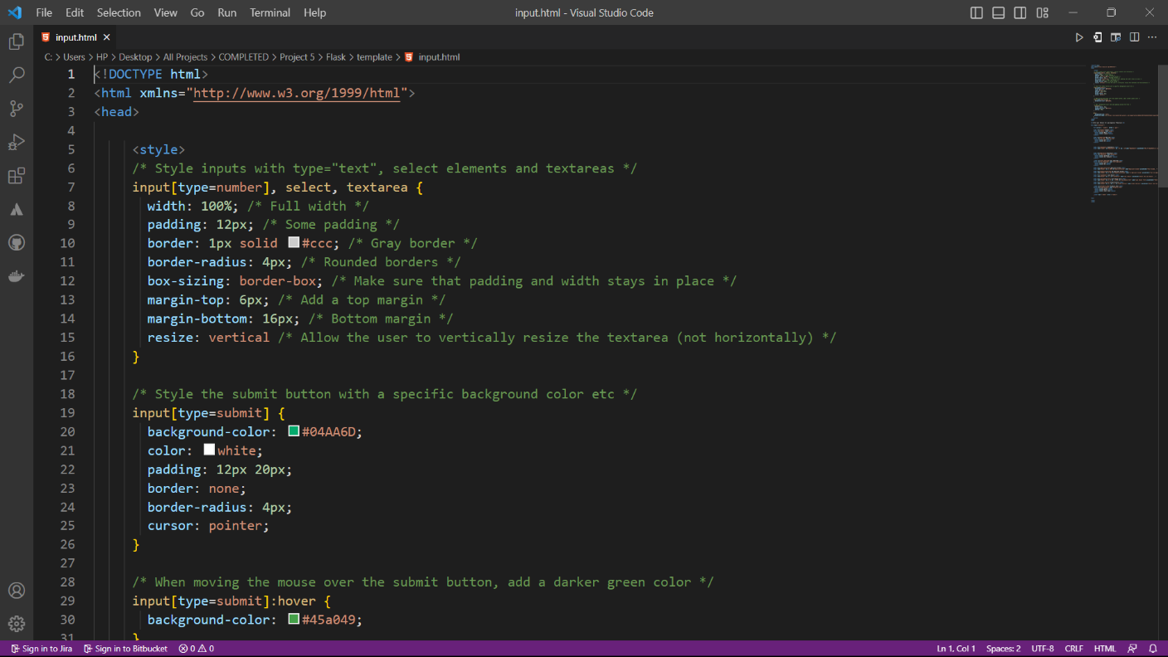

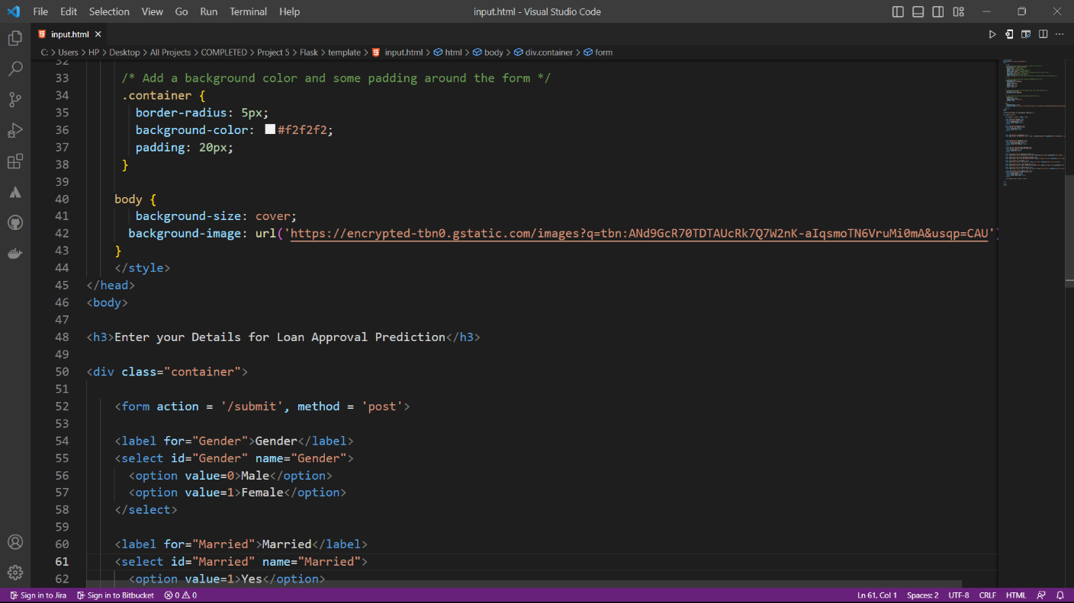

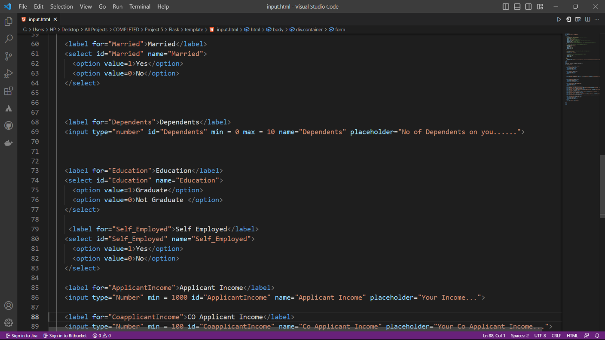

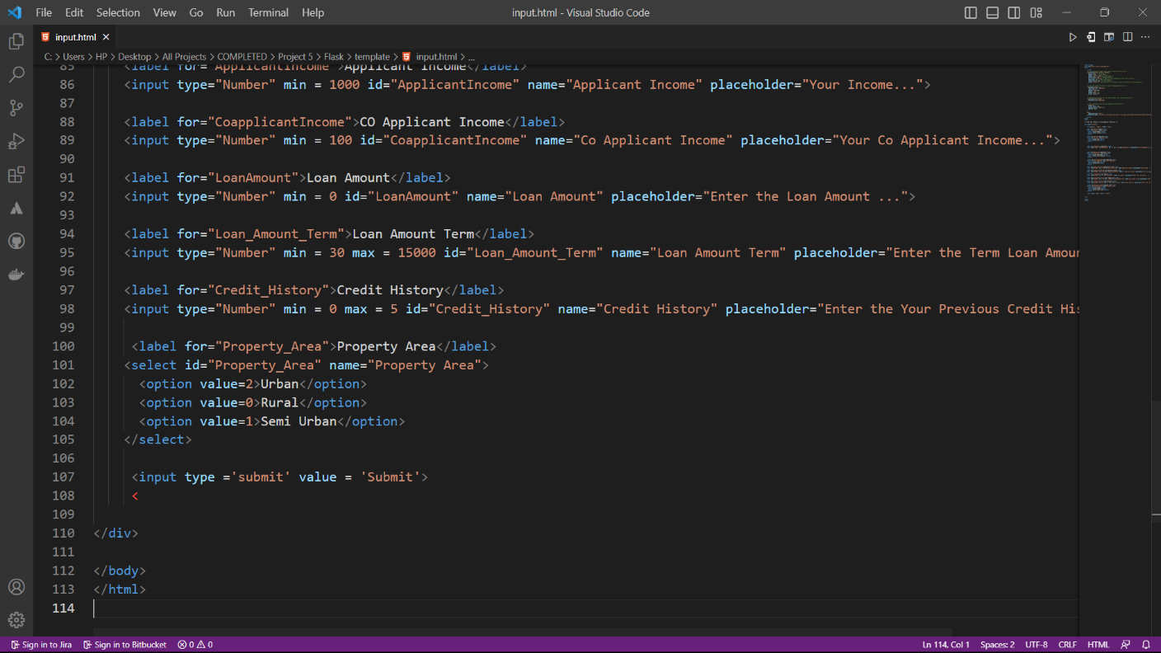

Output.html

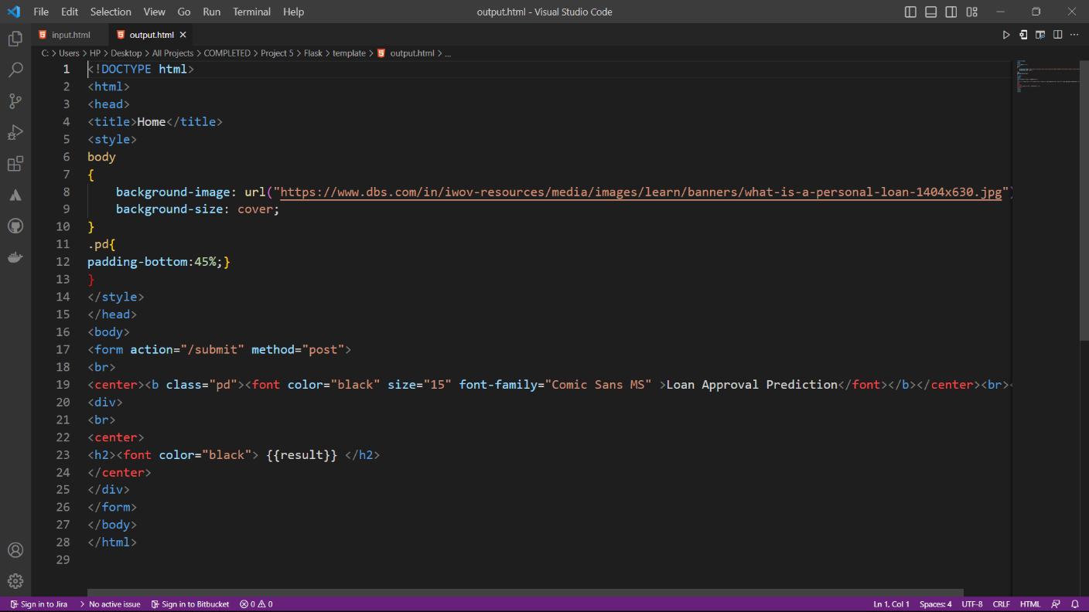

App.py

